Team 10 - The Veil

What's new in this demo:

* This week we fixed the teleport platform bug, player can’t interact with platform in the inappropriate position. The platform will not teleport to a strange place and break the game.
* We fixed the dialogue so it won’t be blocked by the wizard image.
* Changed the Pause and Menu Screens so they are clearer.
* Changed the camera so more of the level is visible.
* We removed the Veil jump, now it’s just a double jump.
* Raven has the new animations of double jumping and death.
* Updated new animations of all the enemies.
* Fixed the background music bugs.

Current controls:

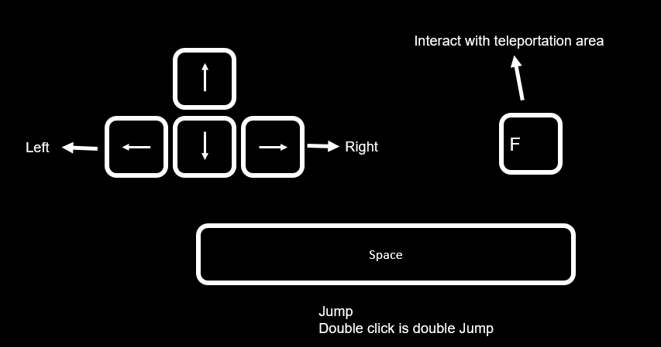

Known issues and bugs:

* At certain points the player can get stuck if they jump to the wrong place.
* Player can still move during death animation.
* Dialogue can be triggered at inappropriate moments.
* Victory Screen does not give accurate time/score at end of game.

Future plan:

* Testing, find out the bugs and plan the solution.
* Fixing bugs.
* Finish implementing art and sound work.
* Adding environmental ambience to the soundtrack (will give player a greater sense of place and soften the harshness of SFX such as jumping and enemy units.)
* **See emailed ‘Proposed Future Implementation’ document**